**LAB 5: RR Scheduling**

**CSE 312 SUMMER 22**

**ID –** 202003112

**Name** – Pranesh Chowdhury

**LAB 5 | RR Scheduling:**

**CODE:**

#include<iostream>

using namespace std;

void CompletionTime(int P[], int n, int BT[], int WT[], int quantum, int AT[], int CT[])

{

int rem_bt[n];

for (int i = 0 ; i < n ; i++)

rem_bt[i] = BT[i];

int t = 0;

while (1)

{

bool done = true;

for (int i = 0 ; i < n; i++)

{

if (rem_bt[i] > 0)

{

done = false;

if (rem_bt[i] > quantum)

{

t += quantum;

rem_bt[i] -= quantum;

}

else

{

t = t + rem_bt[i];

CT[i] = t;

rem_bt[i] = 0;

}

}

}

if (done == true)

break;

}

}

void WaitingTime(int P[], int n, int BT[], int WT[], int quantum, int AT[], int CT[])

{

for (int i = 0; i < n ; i++)

WT[i] = CT[i] - AT[i] - BT[i];

}

void TurnAroundTime(int P[], int n, int BT[], int WT[], int TT[], int AT[], int CT[])

{

for (int i = 0; i < n ; i++)

TT[i] = CT[i] - AT[i];

}

void avgTime(int P[], int n, int BT[], int quantum, int AT[])

{

int WT[n], TT[n], total_wt = 0, total_tat = 0;

int CT[n];

CompletionTime(P, n, BT, WT, quantum, AT, CT);

WaitingTime(P, n, BT, WT, quantum, AT, CT);

TurnAroundTime(P, n, BT, WT,TT, AT, CT);

cout << "PN "<< " \tBT "<< " \tART " << " \t WT " << " \tTAT\n";

for (int i=0; i<n; i++)

{

total_wt = total_wt + WT[i];

total_tat = total_tat + TT[i];

cout << " " << i+1 << "\t" << BT[i] <<"\t " << AT[i] <<"\t "

<< WT[i] <<"\t " << TT[i] <<endl;

}

cout << "\n\nAverage waiting time = " << (float)total_wt / (float)n;

cout << "\nAverage turn around time = " << (float)total_tat / (float)n;

}

int main()

{

int P[] = {1, 2, 3, 4};

int n = sizeof P / sizeof P[0];

int BT[] = {5, 4, 2, 1};

int AT[]= {0, 1, 2, 4};

int quantum = 2;

avgTime(P, n, BT, quantum, AT);

return 0;

}

**CODE IN IDE:**

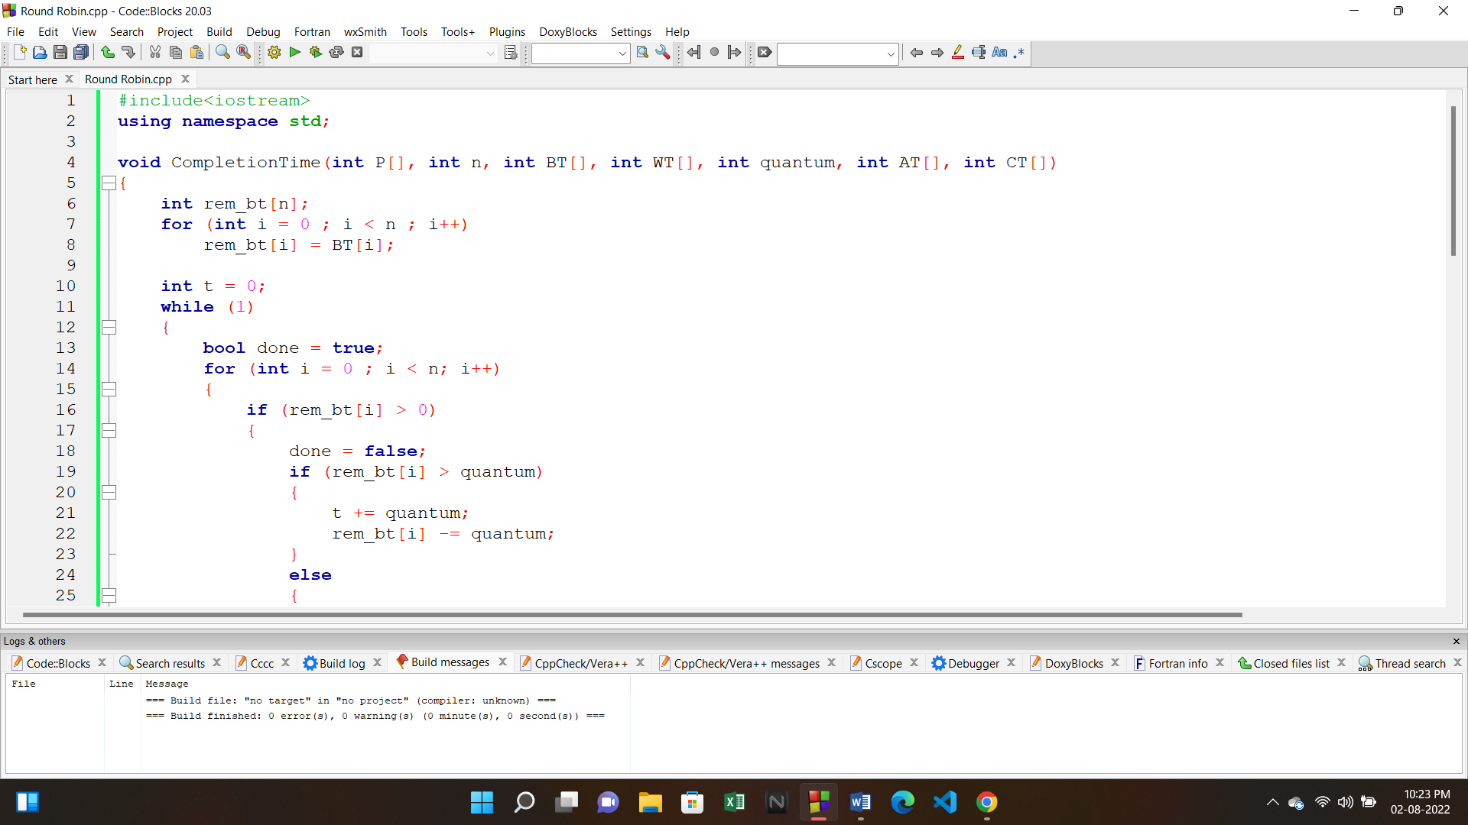

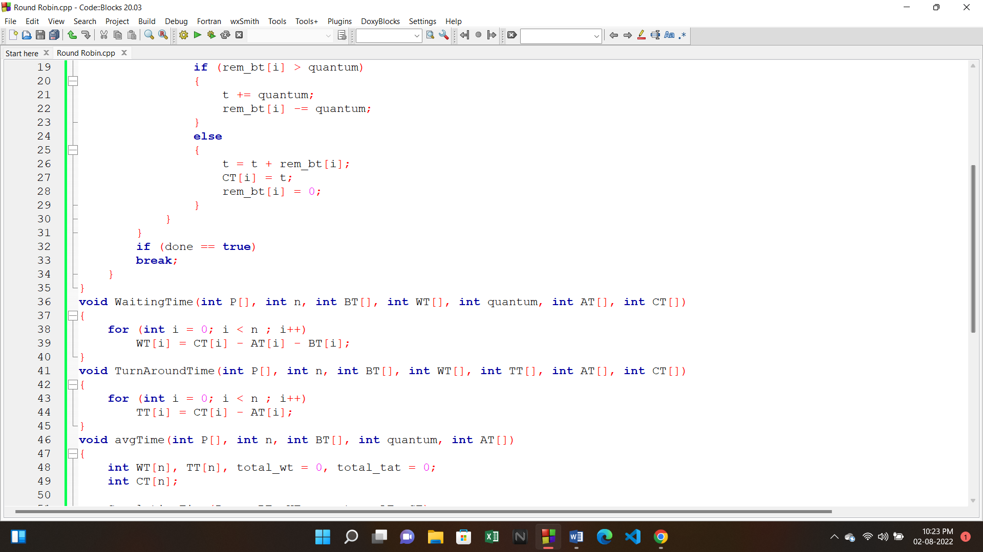

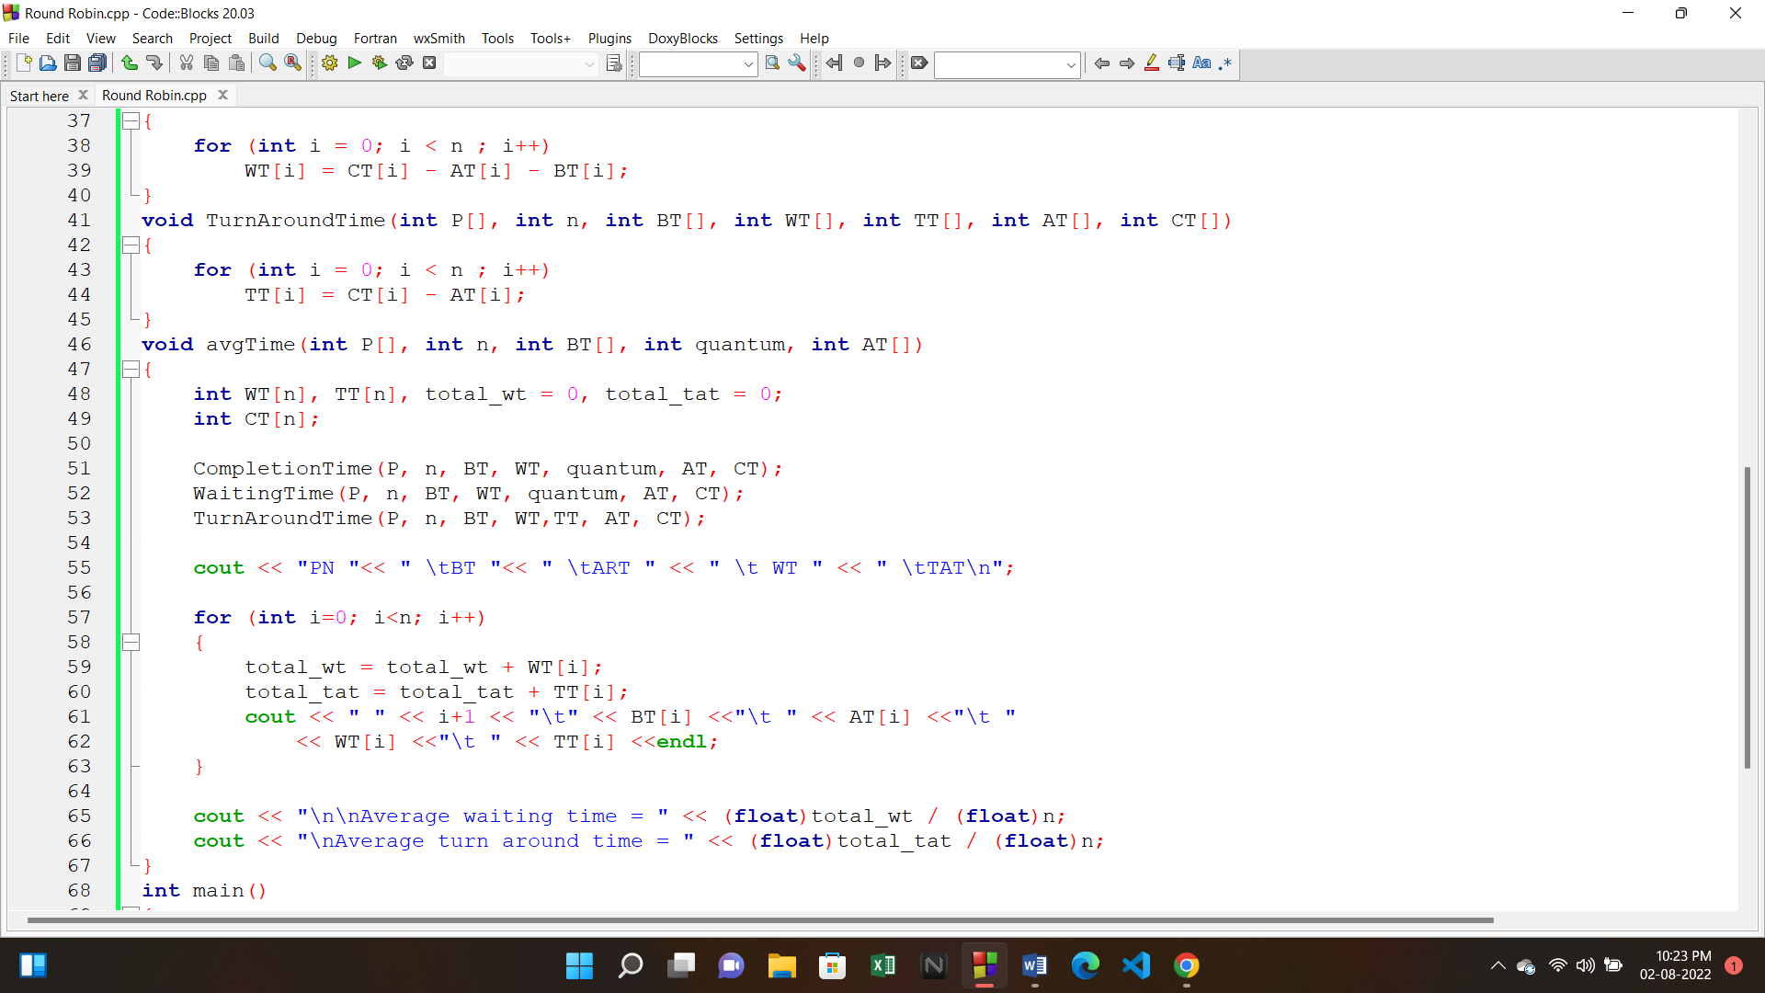

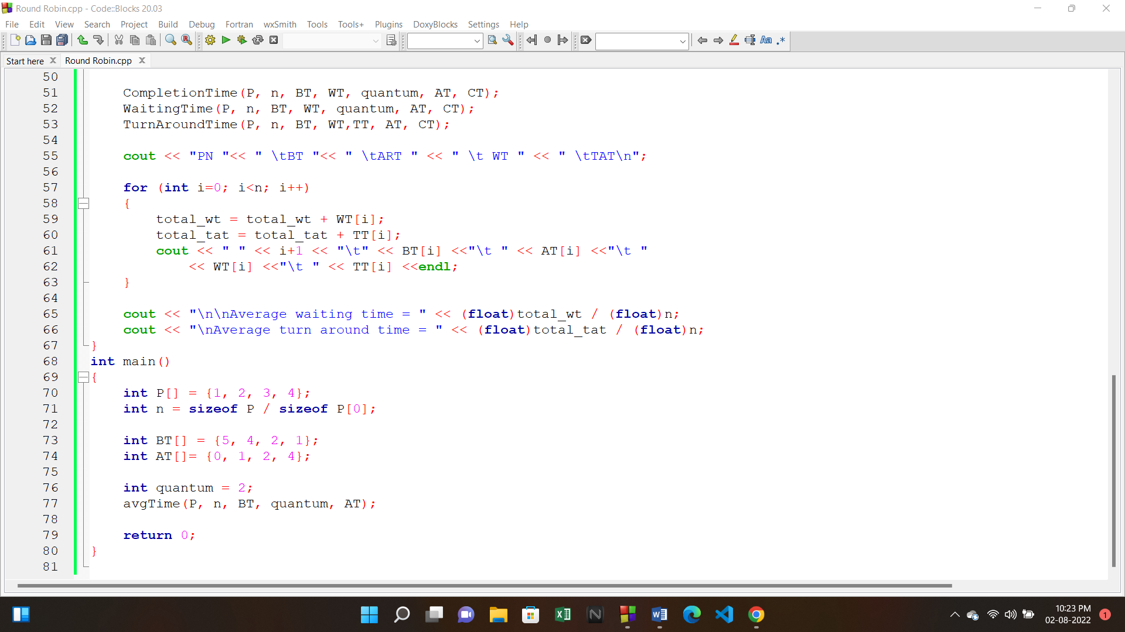

**OUTPUT:**

